**GEMINIA INSURANCE MANAGEMENT SYSTEM**



**TITLE :** GEMINIA INSURANCE MANAGEMENT SYSTEM

**CANDIDATE NAME** : WESAA ALLAN ADAMBO T

**INDEX NUMBER** :1061220190

**CENTER NAME** : KENYA COAST NATIONAL POLYTECHNIC

**COURSE NAME** : DIPLOMA IN NRORAMTION COMMUNICATION TECHNOLOGY

**SUPERVISOR NAME** : MD. R. MRIZI

**SUBMITTED TO** : KENYA NATIONAL EXAMINATIONS COUNCIL FOR AWARD OF DIPLOMA IN INFORMATION COMMUNICATION IN TECHNOLOGY

**DATE :** 15 OCTOBER 2021

**THE KENYA NATIONAL EXAMINATIONS COUNCIL**

DECLARATION FORM FOR DIPLOMA TECHNICAL AND BUSINESS EXAMINATION

NAME OF THE PROJECT: ______________________________________________________

CODE NUMBER OF THE PROJECT: _____________________________________________

**THE CANDIDATE:**

I **______________________________________** of index number _______________________

1. The project named above was approved by KNEC and supervised by

________________________________________________________________

(**SUPERVISOR'S NAME**)

1. I personally carried out the project whose report follows after this declaration
2. I received no undue help from unauthorized persons other than the normal guidance from my supervisor
3. The report submitted to the council is the original work

SIGNATURE _______________________ DATE ___________________________________

____________________________________________________________________________

**THE SUPERVISOR**

I _________________________________ TSC NO __________________________________

(NAME OF SUPERVISOR)

Declare that I supervised the above named candidate's project contained herein as the genuine work of the candidate.

_____________________________ DATE ______________________

SIGNATURE OF THE SUPERVISOR

**Contents**

FABRICATION/DATA COLLECTION 8

A Fact Finding Method 8

A.1 Interview 8

A.2 Record Inspection 8

B Fact Finding Report 10

C Feasibility Study 11

C.1 Technical Feasibility 11

C.2 Operational Feasibility 11

C.3 Legal Feasibility 11

C.4 Economic Feasibility 12

D Current System Operation 13

E Proposed System 15

CHAPTER ONE 18

Introduction 18

1.1 Background of The Organization 18

1.2 Objective of The Project 20

1.3 Current System Operation 20

1.4 Proposed System 22

CHAPTER TWO 25

LITERATURE REVIEW 25

2.1 Introduction 25

2.2 System Review 25

2.2.1 Army Welfare Insurance Agency 25

2.3 System Critique 26

2.4 Research Gap 27

2.5 Summary 27

CHAPTER 3 28

3.1 Objectives of The New System 28

3.1.1 To Design and Implement Geminia Management System 28

3.1.2 To Computerize the Registration of New Agents 28

3.1.3 To Computerize the Registration of New Policy Holders and Claims 28

3.1.4 To track the Policy Premium Payments 28

3.2 Nature of The System 29

3.3 File Design 29

3.4 Input Design 33

3.5 Output Design 40

3.6 Process Design 43

45

3.7 Control Design 46

3.8 Test Design 46

3.9 System Specification. 47

CHAPTER FOUR 48

4.0 System Implementation and Completion 48

4.1 Hardware and Software Specification 48

4.2 User Training 48

4.3 Change Over 49

4.4 System Security 49

4.5 User Guide 49

4.6 Overall Conclusions 52

4.7 Achievements 53

4.8 Limitations Constraints 53

4.9 Future Improvement 53

**Figures**

Figure 1:Record Inspection 9

Figure 2:DFD Level 0 Current System 14

Figure 3:DFD Level 1 Current System 15

Figure 4:DFD Level 1 Proposed System 17

Figure 5:DFD Level 2 Proposed System 17

Figure 6:Geminia Organizational Chart 20

Figure 7:DFD Level Current System 22

Figure 8:DFD Level 1 Current System 23

Figure 9:DFD Level 1 Proposed System 25

Figure 10:Army Insurance Home Page 26

Figure 11:Agent Registration Form 34

Figure 12:Policy Creation Form 36

Figure 13:Policy Claim Form 37

Figure 14:Premium Payment Form 38

Figure 15:Claim Form 39

Figure 16:Accept or Reject Policy Form 40

Figure 17:Delete Customer Policy Form 40

Figure 18:Payment Reciept 41

Figure 19:Available Agents List 41

Figure 20:Policy Holders List 42

Figure 21:Policy Claim List 43

Figure 22:Insurance Type Payment Report 43

Figure 23:All Payments Report 44

Figure 24:System Flowchart 46

Figure 25:Correct Data 47

Figure 26:Incorrect Data 48

Figure 27:Splash Screen 51

Figure 28:Login Form 51

Figure 29:Main Page 52

**Tables**

Table 1:Running Costs for Current System 14

Table 2:Cost for Proposed System 14

Table 3:New Agent Registration File 31

Table 4:New Policy Registration File 31

Table 5:Policy Claim File 32

Table 6:Premium Payment File 32

Table 7:User Account File 33

Table 8:Next of Kin File 33

Table 9:Agent Commission Withdrawal File 33

Table 10:Accepted or Rejected Policies File 34

Table 11:Accepted or Rejected Claims File 34

**Acknowledgment**

It is of my great honor to say thank you, to my Trade Project teacher MD. R. MRIZI for giving me the great opportunity in per taking the GEMINIA INSURANCE MANAGEMENT SYSTEM project and carrying out the necessary research to complete the project.

Furthermore, I do thank most my teacher Mr. Njuguna, for being a wonderful teacher in teaching the Visual Basic Programming for he got me to understand the language making me having few hurdles during the system development.

Lastly, I thank Almighty God for being with me till the project completion time and I do say thank for all the help I got from my wonderful associates.

**Abstract**

Fabrication and data Collection contains all about the system analysis techniques such as fact finding methods, feasibility study and finally gives report on the finding report all this in order to ensure the components of the system work efficiently to accomplish the key user requirements and the defined objectives.

Chapter One contains the background information of the organization, objectives of the project and defined in details the information contained in operations of both the current system and the proposed solution.

Chapter Two contains more information about your system and existing systems. This chapter describes the weaknesses of the existing system and how my system would improve on what is already available in the market today.

Chapter Three contains the detail definition of each objective, then shows the file design, input design with their screenshots and output design with their screenshots. The chapter also defines the system specification involved for the smooth running of the system and the test design.

Chapter Four is about system implementation defining in details the user training, the type of changeover technique used, system security and finally gives the user guide of navigating the system. It also clearly states the degree of success of the system, achievements involved, limitations constraints, system future improvements, program listing, Appendix, and design tools.

# 

# **FABRICATION/DATA COLLECTION**

## A Fact Finding Method

The below techniques were used to obtain information that would be necessary for the development of the proposed system.

### **A.1 Interview**

This method of fact finding was used to get more information from persons involved in running of the company to gain insight on how the company works. Different persons were interviewed as follows:

**Branch Manager**

When did the Company start?

Please briefly explain the organizational structure of Geminia Insurance?

What are the different types of Insurance Coverage in Geminia Insurance?

**Underwriting Manager**

Who is an Underwriting Manager? And what are his/her roles?

Is the Underwriting manager also responsible for policy claims?

How does Geminia Insurance Capture data in policy creation and policy claim?

Briefly explain the registration of new agents and responsibilities of agents?

### **A.2 Record Inspection**

The reason to use this type of data collection was to gain more insight of the produced documents and records used in the current system of Geminia Insurance Company. I managed to go through different documents kept in the organization such as policy claim form, policy creation form and receipt generated. This helped in obtaining relevant information from the organization concerning the current system.

The Pictures below were obtained from Geminia Insurance Limited In Order to gain more insight on how the company works.

Figure 1:Record Inspection

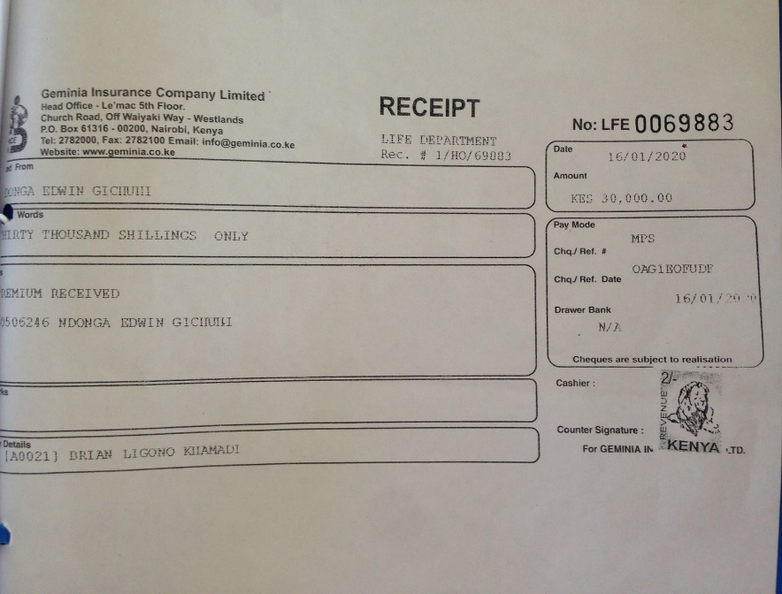

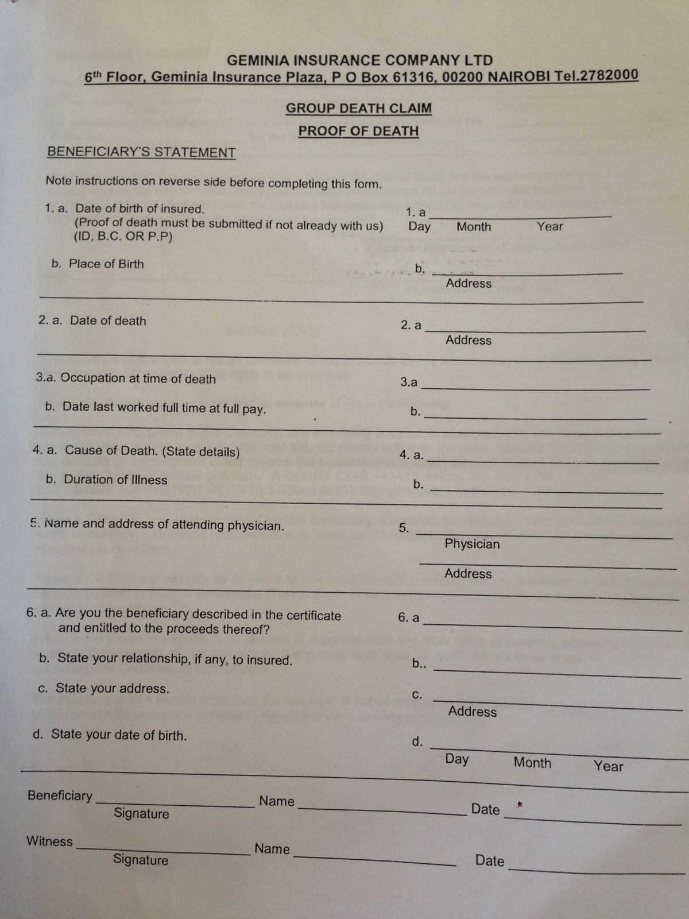

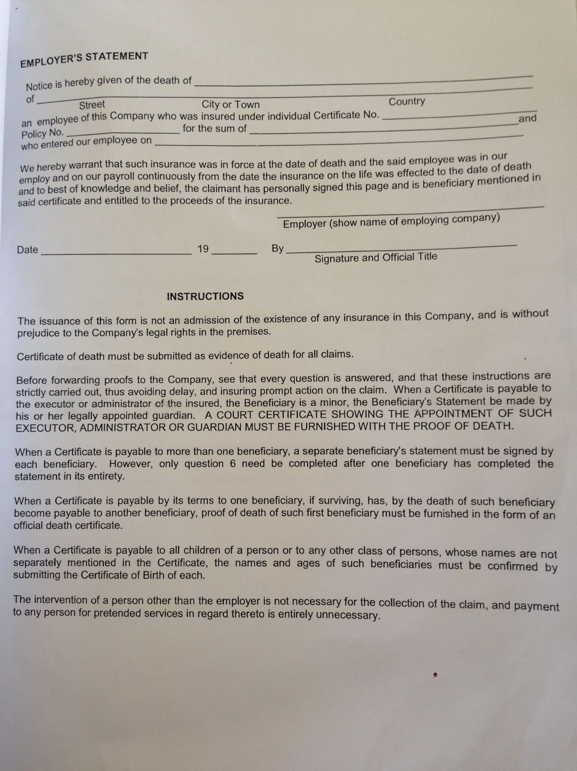

## B Fact Finding Report

The current system in operation begins by recruiting of sales agents. The agent’s details are captured such as Agent’s Name, ID Number, Phone Number and Residence. The Agents are responsible for bringing in new customers and in turn payment of the Agents is done based on the targets achieved.

New customers should provide details in order for registration. Customer Name, Age, ID Number, Phone Number and the type of Insurance are the details captured. The Underwriting Manager then is responsible for verifying the policy application and based on the organization guidelines he/she can accept or reject the application.

During premium payments, the policy holder details would then be captured e.g. Name, Policy Number, ID Number and paid on cash. The policy holder is then issued a receipt.

In order to apply for a claim, the claimant must be a policy holder and actively be paying premiums. The claimants’ details are captured and forwarded to the claim manager who sends people to verify the claim. Based on the report the claimant can then be compensated or the claim rejected.

The Underwriting manager is responsible for keeping the policy documents of customers. The claim manager is responsible for keeping the policy claim documents. The Accountant keeps track of payment documents.

In conclusion, the overall operation of the current system involves too much manual work and higher duplication of the captured records.

## C Feasibility Study

This was to find out if it is viable to replace the current system in operation. Several studies had to be conducted to assess how positively the system will impact in terms of improving efficiency, time and cost associated in running it. The studies conducted are described as follows:

### **C.1 Technical Feasibility**

This was to identify the important hardware and software necessary for the efficient performance of the new system in terms of its ability to process certain number of transactions within a given period of time.

Furthermore, the proposed system can easily be maintained and repaired without requiring high experts or technical support because the system will be installed in adaptable technology and the employees of the organization have basic knowledge about technology. Through training the employees can easily manage the system.

### **C.2 Operational Feasibility**

The system will perform all the operations as per the objectives. It will involve less human labor as it will computerize the activities offering a user friendly interactive environment. Data will be captured into the system through use of keyboards, mouse and use various buttons to save, delete and generate reports for the stored data.

### **C.3 Legal Feasibility**

This was in order to make sure that all the carried out operations are not going against the laws of Kenya. For instance, the system is mainly operational in data entry, I will make sure that the system will adhere to all the data entry laws of Kenya such as not capturing policy holder’s details without his or her consent.

### **C.4 Economic Feasibility**

This was to evaluate the effectives of the proposed system if it is cost saving. The main activities took up much paperwork which is costly. An improvement in the proposed system will increase the productivity of carrying out operations in the organization and reduce cost of the organization. The study touched the cost benefit analysis for both the proposed system and current system in terms of things invoiced in carrying out operations.

**Running Cost for the current system**

Recurring costs

|  |  |
| --- | --- |
| **Items** | **Amount** |
| File Cabinets | 20,000 |
| Stationary | 30,000 |
| Photocopy | 2,000 |
| **Total** | **52,000** |

Table 1:Running Costs for Current System

**Proposed System**

|  |  |
| --- | --- |
| **Items** | **Amount** |
| Software Installation | 2,000 |
| Printing | 3,000 |
| Training | 10,000 |
| Papers | 500 |
| **Total** | **15,500** |

Table 2:Cost for Proposed System

## D Current System Operation

In Geminia Current System, agents aspiring to work for the insurance company fill in a form about their details e.g. Name, Age, Residence, ID Number, Phone Number. The sales agents are responsible for bringing in a new customer.

The new customers then apply for policy where their details are captured i.e. Name, Age, ID Number, Phone Number, Type of Insurance he/she wants to buy. The forms are then brought to the underwriting manager who verifies the policy application and is responsible for accepting or rejecting the application.

Premium payment is also manually done where a policy holder is required to visit the premises in order to make payment and be issued with a receipt by the company.

Applying for a policy claim also requires one to fill a document called policy claim form. Details like Policy Holder Name, Residence, Age, Reason for claim, are captured. The forms are then brought to the claim manager. The claim manager is responsible for investigating the occurrence and can accept or reject the claim.

The whole process is time consuming due to the fact that data is captured and verified manually. Security of the policy holder’s record is not effective because there is no back up plans put in place for the Policy Holder’s records.

The following is the DFD level 0 and 1 showing the various processes that are in the current system.

**Level 0**:

Compensation

Policy Holder

Agent’s

GEMINIA INSURANCE CO.

Agents

Details

Figure 2:DFD Level 0 Current System

**Level 1**:

Policy

Customer

Customer

Agent

Agent

Details

Details

Recording Customer details

Details

Recording Agent Details

Agent

Accept/Reject Policy

Verification

Underwriting Manager

Verification of policy agreement

Policy Details

Payment Details

Payment

Recording Premium payment

Claim

Compensation

Policy Holder

Recording Claim

Accept/Reject claim

Reports

Claim Manager

Figure 3:DFD Level 1 Current System

## E Proposed System

The system is designed to eliminate the drawbacks of the existing system in order to provide a permanent solution to the system’s problems. It will provide a graphical environment interface for registering new agents into the system. The agent’s details i.e. Name, Age, ID Number, Phone Number and Residence are captured and stored in a database. The system automatically generates an agent number which will be linked with policy creation which allows easy calculation of Agent’s commission.

The system will also capture details of new customers e.g. Name, Age, ID Number, type of Insurance and payment plan. This details will in turn be accessible to the underwriting manager through the system who will verify the application based on organizational policies and thereafter approve or reject the application. The whole process will be computerized and details saved in the database.

The system will also be able to keep track of the premium payments by customers. Details of the payments e.g. Name of Policy Holder, Amount, Month and Mode of payment will be captured and stored. The details will be used to print receipts.

Furthermore, the system will computerize the policy claim process where a claimant’s details will be captured e.g. Policy Number, Name and reason for claim. Claim manager who is responsible for accepting or rejecting the claim will verify the authenticity of claimant and investigate the claim.

The following are DFD level 1 and 2.

**Level 1:**

Policy

Customer

Customer

Agent

Agent

Details

Details

Recording Customer details

Details

Recording Agent Details

Admin

Accept/Reject Policy

Verification

Underwriting Manager

Verification of policy agreement

Policy Details

Payment Details

Payment

Recording Premium payment

Claim

Compensation

Policy Holder

Recording Claim

Accept/Reject claim

Reports

Claim Manager

Figure 4:DFD Level 1 Proposed System

**Level 2:**

Figure 5:DFD Level 2 Proposed System

Customer Details

2

Agent Details

a

1

Agent

Policy

Customer

Customer

Agent

Details

Details

Recording Customer details

Details

Recording Agent Details

Admin

Accept/Reject Policy

Verification

Underwriting Manager

Verification of policy agreement

Policy Details

Payment Details

Accept/Reject Policies

4

Payment Details

3

Payment

Recording Premium payment

Claim

Compensation

Policy Holder

Recording Claim

5

Claim Details

Accept/Reject claim

Reports

Claim Manager

Accept/Reject Claim

6

# **CHAPTER ONE**

## 1.0 Introduction

## 1.1 Background of The Organization

Geminia Insurance Company Limited is a fully locally owned Insurance Company founded in 1981. The company however started its Insurance operations in April 1982 in General Insurance and diversifying into Life Assurance in 1992. It is licensed to transact both General and Life business.

As a company with a long term perspective, it has established a proven track record of efficient and personalized services to all its clients.

Below is Geminia’s Organizational Structure:

**Branch Manager**

Responsible for all the operations done at Geminia Insurance Company Mombasa Branch

**Assistant Manager**

Answers to the Branch Manager. Also responsible for managing all the activities when the branch manager is not available.

**Underwriting Manager**

Responsible for verifying policy applications submitted. Can Accept or Reject the Policy applications.

**Claim Manager**

Responsible for verifying the claim applications submitted. Can Accept or Reject claims based on the report.

**Regional Manager**

Responsible for Policy Creation Activity.

**Unit Manager/Team Leader**

Responsible for assigning tasks to the agents. Manages the agents.

**Accountant**

Responsible for all calculations of finances in the company.

**Agents**

Responsible for bringing in new customers in the organization.

Branch Manager

Assistant Branch Manager

Claim Manager

Underwriting Manager

Accountant

Regional Manager

Unit Manager/Team Leader

Reception

Agents

Figure 6:Geminia Organizational Chart

## 1.2 Objective of The Project

To design and Implement Geminia Insurance Management System. The proposed system will improve on the current system by ensuring smooth running of activities in Geminia Insurance company. The system will manage policy holders and agent’s record, register new policy holders and agents, improve on premium payments record keeping. The system will also minimize workloads of the employees, improve on performance and largely reduce on the use of paperwork.

Computerize the registration of new agents. The system will provide easy to use agent registration form which would capture details of new agents aspiring to work for Geminia Insurance Company. By capturing agent information on any new registering policy holders the system will also be able to calculate the agent’s commission.

To computerize the registration of new policy holders and policy claims. The system will allow easy capture of customer details obtaining new policy. The system will manage the captured data in order to easily access the data. The system will also computerize the policy claim and capture claimant’s details which will be accessible to the claimant manager who can Accept or Reject the claim.

To track the policy premium payment. The system will track the payment of premiums by the customers i.e. monthly or yearly. Details of the payment will be stored in the database for the transparency. The system will also generate receipt for the customers as proof for the payment.

## 1.3 Current System Operation

In Geminia Current System, agents aspiring to work for the insurance company fill in a form about their details e.g. Name, Age, Residence, ID Number, Phone Number. The sales agents are responsible for bringing in a new customer.

The new customers then apply for policy where their details are captured i.e. Name, Age, ID Number, Phone Number, Type of Insurance he/she wants to buy. The forms are then brought to the underwriting manager who verifies the policy application and is responsible for accepting or rejecting the application.

Premium payment is also manually done where a policy holder is required to visit the premises in order to make payment and be issued with a receipt by the company.

Applying for a policy claim also requires one to fill a document called policy claim form. Details like Policy Holder Name, Residence, Age, Reason for claim, are captured. The forms are then brought to the claim manager. The claim manager is responsible for investigating the occurrence and can accept or reject the claim.

The whole process is time consuming due to the fact that data is captured and verified manually. Security of the policy holder’s record is not effective because there is no back up plans put in place for the Policy Holder’s records.

The following is the DFD level 0 and 1 showing the various processes that are in the current system.

**Level 0:**

Compensation

Policy Holder

Agent’s

GEMINIA INSURANCE CO.

Agents

Details

Figure 7:DFD Level Current System

Policy

Customer

Customer

Agent

Agent

Details

Details

Recording Customer details

Details

Recording Agent Details

Agent

Accept/Reject Policy

Verification

Underwriting Manager

Verification of policy agreement

Policy Details

Payment Details

Payment

Recording Premium payment

Claim

Compensation

Policy Holder

Recording Claim

Accept/Reject claim

Reports

Claim Manager

Figure 8:DFD Level 1 Current System

## 1.4 Proposed System

The system is designed to eliminate the drawbacks of the existing system in order to provide a permanent solution to the system’s problems. It will provide a graphical environment interface for registering new agents into the system. The agent’s details i.e. Name, Age, ID Number, Phone Number and Residence are captured and stored in a database. The system automatically generates an agent number which will be linked with policy creation which allows easy calculation of Agent’s commission.

The system will also capture details of new customers e.g. Name, Age, ID Number, type of Insurance and payment plan. This details will in turn be accessible to the underwriting manager through the system who will verify the application based on organizational policies and thereafter approve or reject the application. The whole process will be computerized and details saved in the database.

The system will also be able to keep track of the premium payments by customers. Details of the payments e.g. Name of Policy Holder, Amount, Month and Mode of payment will be captured and stored. The details will be used to print receipts.

Furthermore, the system will computerize the policy claim process where a claimant’s details will be captured e.g. Policy Number, Name and reason for claim. Claim manager who is responsible for accepting or rejecting the claim will verify the authenticity of claimant and investigate the claim.

The diagram below represents level 1 DFD for the proposed system.

**Level 1:**

Policy

Customer

Customer

Agent

Agent

Details

Details

Recording Customer details

Details

Recording Agent Details

Admin

Accept/Reject Policy

Verification

Underwriting Manager

Verification of policy agreement

Policy Details

Payment Details

Payment

Recording Premium payment

Claim

Compensation

Policy Holder

Recording Claim

Accept/Reject claim

Reports

Claim Manager

Figure 9:DFD Level 1 Proposed System

# **CHAPTER TWO**

## 2.0 LITERATURE REVIEW

## 2.1 Introduction

The main purpose of this chapter is to show connection between what is proposed i.e. Geminia Insurance Management System with other existing system. It also aims to draw distinction between the two and hence decision based on cost effectiveness.

## 2.2 System Review

The system proposed i.e. Geminia Insurance Management System will greatly reduce on paperwork where customer details will be captured directly using a Graphical User Interface form. This will be much faster and reduce on loss of data since there will be a central database which will store all the information. The system has been tested by registering new agents, registering new Policy Holders, filling in new claims and capturing premium payment details and each time it produced accurate results. The system will also generate reports based on the information captured which will help the organization make informed decisions. Admin will have full access to the system and will be responsible for accepting/rejecting the policies and claims.

### **2.2.1 Army Welfare Insurance Agency**

The Army Insurance is a desktop application system that allows the registration of new customers and policy holders.

The system also captures policy claims, and allows Admin and normal user login.

It also allows operating of user passwords and create new policies. The details captured will be useful in calculating the amount to pay for premiums, making reports which enhances decision making.

Below Is a screen capture of the Insurance Management System used in Army Welfare Insurance Agency.

Follow the link to view the mentioned system(Army Welfare Insurance Agency) ***projectsgeek.com/visual-basic-projects-with-source-code***

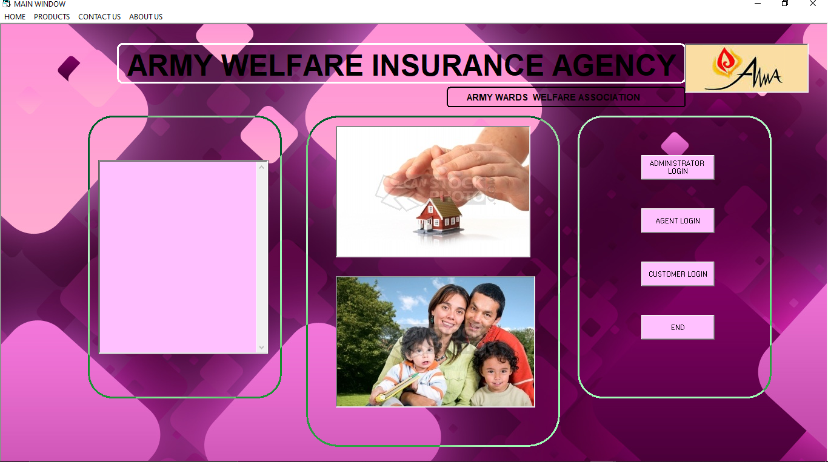

Figure 10:Army Insurance Home Page

## 2.3 System Critique

In the above mentioned institution it is evident that Insurance Management system is available, however most of the systems are majorly for capturing data mostly the customers and the agents. The system does not capture processing activities like premium payment which is an important aspect of every insurance firm. This leaves the premium payment process full of errors.

The system also does not provide a clear link between the agent and the customer. This leaves it hard to calculate the agent fees since the record was not captured and recorded.

Lastly the system does not reduce redundancy. The details captured in the customer registration are the same details captured in customer registration are the same details captured in creating policy this in turn leads to data redundancy which could be avoided.

## 2.4 Research Gap

In this proposed system, processing activities like premium payments are captured. This makes the whole system computerized and all the details are stored in a central database. Data can be retrieved whenever needed.

Also the proposed system provides a clear link between every new registering customer and an agent. This will be helpful in calculating all the agent fee.

Lastly the system proposed will aim to reduce redundancy as the tables have been normalized. This makes the proposed system more efficient than the ones in place.

## 2.5 Summary

Geminia Insurance System will be a useful tool that will help in data collection techniques of Geminia. It saves time that a customer can fill in a form and reduces a lot of paperwork. Data captured will be accessible as both the documentation and data available will be given.

# **CHAPTER 3**

## 3.1 Objectives of The New System

### **3.1.1 To Design and Implement Geminia Management System**

The proposed Insurance Management system will improve on the current system by ensuring smooth running of daily activities of the company. It would help in computerization of activities such as registration of new policy holders, registration of new agents and computerization of premium payments by policy holders. This would help in efficiency and greatly reduce on errors hence maximizing on performance of Geminia Insurance.

### **3.1.2 To Computerize the Registration of New Agents**

The proposed system will provide easy to use agent registration form which would capture details of new agents aspiring to work with Geminia Insurance Company. The system will then automatically assign an agent number to every agent registered. The Agent Number will be captured on any new registering policy holder which in turn will help the system to calculate the agent’s commission.

### **3.1.3 To Computerize the Registration of New Policy Holders and Claims**

The proposed system will provide a registration form where new customers’ details will be captured i.e. Name, Residence, Type of Policy and contact information. This data will securely be stored and managed. The claim manager will verify the policy agreement and accept or reject the policy.

Furthermore, the system will also provide a claim form where a policy holder who has incurred a loss can file a claim through use of the system. Details e.g. Policy Number, Date, Place, Description will be captured and be available through use of the system. The claim manager will assess the occurrence on the ground and file a report on the system accepting or rejecting the claim.

### **3.1.4 To track the Policy Premium Payments**

The Proposed system will help in keeping track of premium payments by Policy Holders. Payment plans which include Full Amount, Semi Annually and quarterly will be recorded and stored in the database. The system will then generate receipts to the customers and also generate reports based on the payments.

## 3.2 Nature of The System

Geminia Insurance Management System will be a computerized system dealing with all activities of the company. It will be a system that will offer real time results whereby users of the system will interact with an easy to use system which will enhance faster and efficient registration of new agents, registration new policy holders, policy premium payments and policy claims.

The system will provide a large storage capability for the enormous data from the Geminia Insurance operations through a relational database (Microsoft Access) which will be integrated with the system. It will hence provide an easy access and retrieval of tenants details if needed.

## 3.3 File Design

This section shows the records and data that will be collected using the new system and the files that the data is going to be stored in.

The following are the files that will be used in development of the system.

**New Agent Registration File**

This file would be used to register new agents working for Geminia.

|  |  |  |
| --- | --- | --- |
| **Field Name** | **Data Type** | **Description** |
| Agent_Number | Auto number | Unique Key to Identify specific Agent |
| Agent_Name | Short Text | Agent’s Full Name |
| ID_Number | Number | Agent’s National Identification Number |
| Mobile_Number | Number | Agent’s Contact Information |
| Gender | Short Text | Agent’s Number |
| Email | Short Text | Agent’s Email |
| Residence | Short Text | Residence of the Agent |
| County | Short Text | County where agent resides |

Table 3:New Agent Registration File

**New Policy Registration File**

The file will be used to record Information about new customers buying new policy in the Company.

|  |  |  |
| --- | --- | --- |
| **Field Name** | **Data Type** | **Description** |
| Policy_Number | Auto Number | Unique key to identify a specific policy |
| Holder_Name | Text | Customer’s full names |
| Id_Number | Number | National Identification Number |
| Mobile_Number | Number | Customer’s contact details |
| Residence | Text | Where customer resides |
| Policy Type | Text | The type of insurance e.g. Accident |
| Gender | Text | Customer’s Gender |
| Agent_Number | Number | Agent number of Agent who referred customer |
| Date_Created | Date/Time | Date of Policy Creation |
| Date_of_Birth | Text | Birth Date Customer. Calculates Age |
| Email | Text | Contact Information |

Table 4:New Policy Registration File

**Policy Claim File**

File Used to record details of customers who are filing for a policy claim.

|  |  |  |
| --- | --- | --- |
| **Field Name** | **Data Type** | **Description** |
| Policy_Number | Number | Policy Number of the claimant |
| Claimant_Name | Text | Full Names |
| Claim_Type | Text | Type of Insurance Claim |
| Claim_Number | Auto Number | Unique key Identifying a specific claim |

Table 5:Policy Claim File

**Premium Payment File**

File used to record all Insurance payments made to the company.

|  |  |  |
| --- | --- | --- |
| **Field Name** | **Data Type** | **Description** |
| Payment_Id | Auto Number | Unique key to identify a specific payment |
| Policy_Type | Text | Insurance type e.g. Motor |
| Insurance_Price | Currency | Price of the Insurance |
| Received_By | Text | Person who received the payment |
| Payment_Mode | Text | Either Cash or Mobile Money |
| Date_Paid | Date/Time | Date of the payment |
| Amount_Paid | Currency | Actual Amount paid by policy holder |
| Balance_Rem | Currency | Remaining balance according to payment plan |
| Payment_Plan | Text | Either full amount or in installments |

Table 6:Premium Payment File

**User Accounts File**

This file would be used to create system users for the new system.

|  |  |  |
| --- | --- | --- |
| **Field Name** | **Data Type** | **Description** |
| UserName | Text | Name of the User |
| Password | Text | Password of the user |
| Type_of_User | Text | Rights of the user i.e. Admin or normal user |
| User_Id | Auto number | Unique key to identify user |

Table 7:User Account File

**Next of Kin File**

File used to record contact information of next of kin to the customer.

|  |  |  |
| --- | --- | --- |
| **Field Name** | **Data Type** | **Description** |
| Policy Number | Number | Policy Number of policy holder |
| Name of Kin | Text | Full Name of the kin |
| Mobile Number | Number | Contact information of the next of kin |
| Relation | Text | Relation to the policy holder |
| Residence | Text | Where next of kin resides |

Table 8:Next of Kin File

**Agent Commission withdraw**

File used to record commission withdrawal of agents working with the Insurance Company.

|  |  |  |
| --- | --- | --- |
| Field Name | Data Type | Description |
| Agent_Number | Number | Unique key to identify agent paid |
| Agent_Name | Text | Name of the agent |
| No_of_Customers | Number | Number of customers agent brought |
| price | Currency | Price of bringing a customer |
| Total_commission | Currency | Total commission paid to the agent |
| Month_Paid | Text | Month for which agent is being paid |
| Payment_Mode | Text | Either cash or mobile money |
| Date_Paid | Date/Time | Date agent is paid |

Table 9:Agent Commission Withdrawal File

**Accepted or Rejected Policy File**

File recording details of Policies which have either been accepted or rejected by the underwriting manager.

Table 10:Accepted or Rejected Policies File

|  |  |  |
| --- | --- | --- |
| Field Name | Data Type | Description |
| Policy Number | Number | Unique key to identify a specific policy |
| Holder Name | Text | Holder’s Name |
| Policy Type | Text | The Insurance type bought |
| Reason | Long Text | Reason for accepting or rejecting the policy |
| Policy Status | Text | Accepted or Rejected |
| Date | Date/Time | Date decision was made |

**Accepted or Rejected Claims File**

File recording details of claims which have either been accepted or rejected by the claim manager.

|  |  |  |
| --- | --- | --- |
| **Field Name** | **Data Type** | **Description** |
| Policy_Number | Number | Unique key to identify a specific claim |
| Report | Long Text | Assessor’s report |
| Status | Text | Accepted or Rejected |
| Date | Date/Time | Decision Date |

Table 11:Accepted or Rejected Claims File

## 3.4 Input Design

This phase describes the various input forms used to carry out different operations with the new system, Geminia Insurance Management System.

The following are sample of input designs used in the system.

**New Agents Registration Form**

This is the input form used to register new Agents.

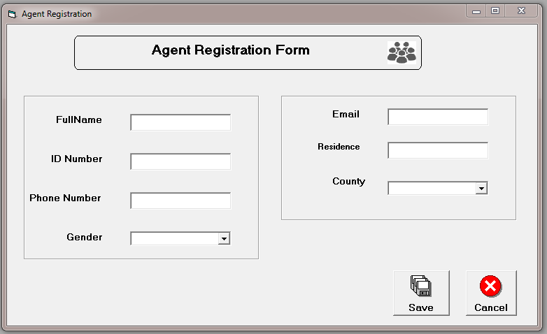

Figure 11:Agent Registration Form

**New Policy Registration Form**

This is the form used to register new policy holders.

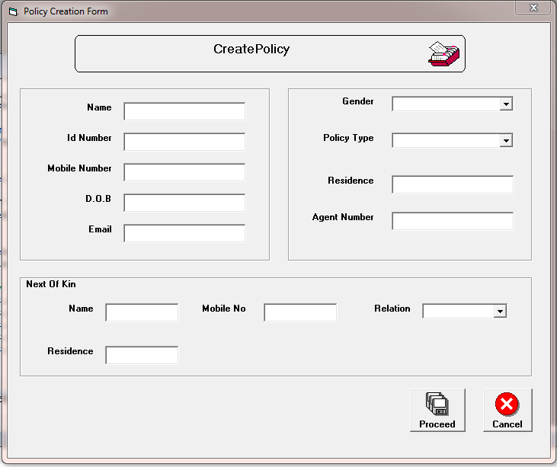

Figure 12:Policy Creation Form

**Policy Claim Form**

Form used to capture claimant information.

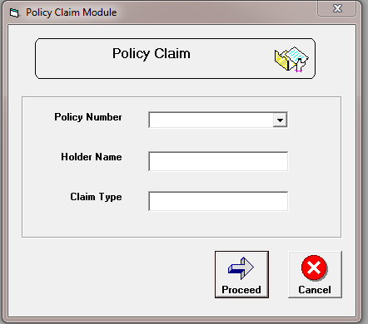

Figure 13:Policy Claim Form

**Policy Payment Form**

Form used to payment details of policy payments.

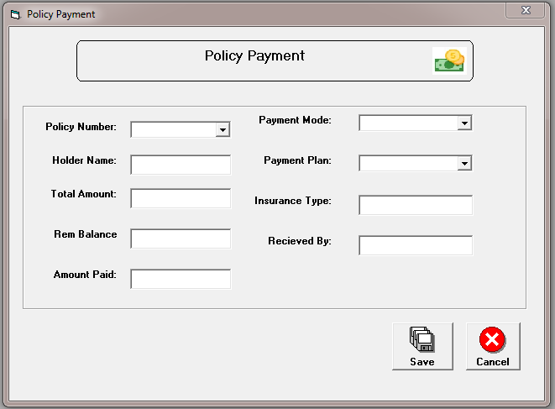

Figure 14:Premium Payment Form

**Accept or Reject Claim**

Available to the underwriting manager who has admin privileges. Can Accept or Reject Policy agreement based on company policy.

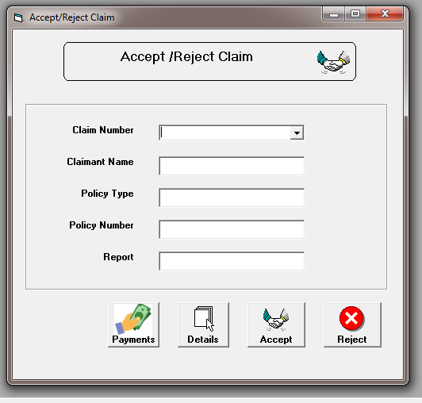

Figure 15:Claim Form

**Accept or Reject Policy Form**

Available to the underwriting manager who has admin privileges. Can Accept or Reject Policy agreement based on company policy.

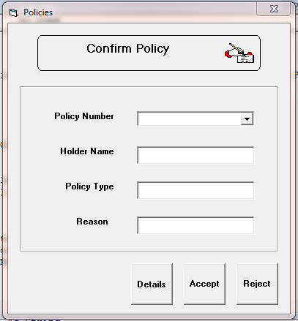

Figure 16:Accept or Reject Policy Form

**Delete Customer Policy Form**

This form is used to delete a Customer policy from the central database.

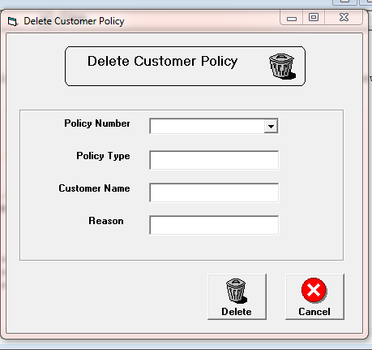

Figure 17:Delete Customer Policy Form

## 3.5 Output Design

This will show the result of the input from the system layout of the data captured.

**Payment Receipt**

Output design generated once a customer completes a payment.

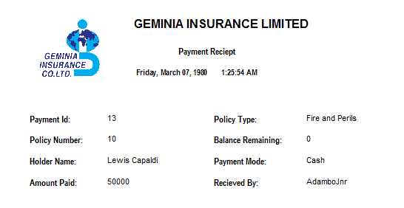

Figure 18:Payment Reciept

**Available Agents List Report**

This shows a list of all available agents working for the company.

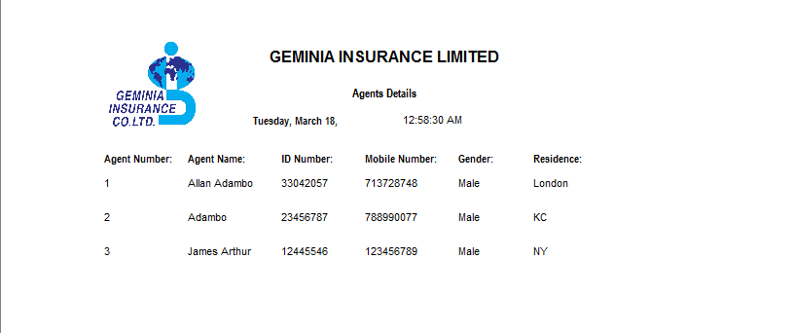

Figure 19:Available Agents List

**Policy Holders List**

This output design shows details of Policy holders in the company.

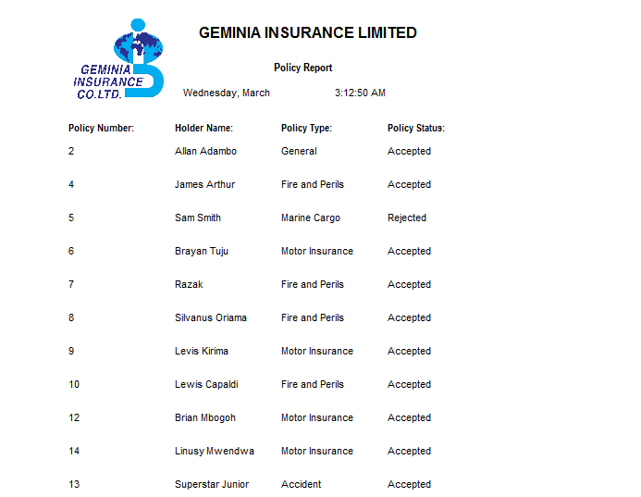

Figure 20:Policy Holders List

**Policy Claim List Report**

Output design showing list of all claimants in the company.

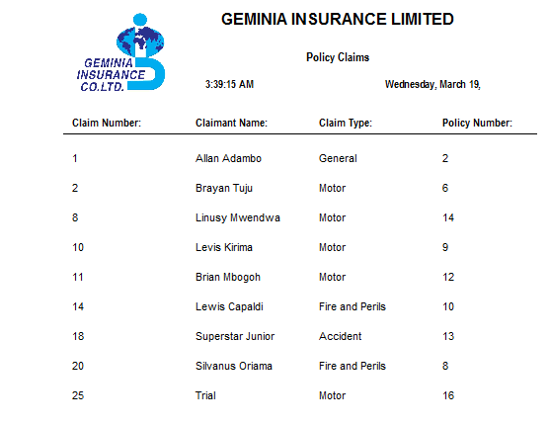

Figure 21:Policy Claim List

**Insurance Account Payment List**

Shows payment history of a specific type of insurance.

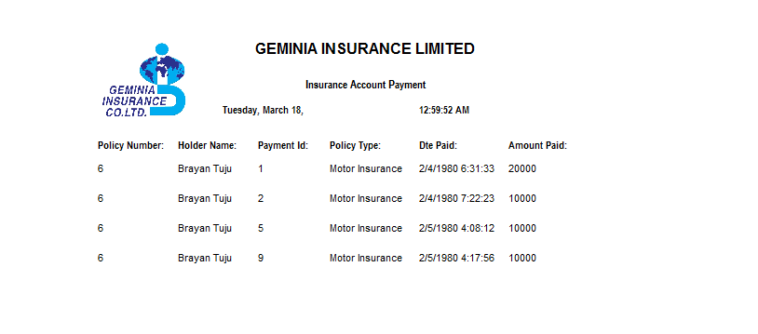

Figure :Insurance Type Payment Report

**All Payments List Report**

This output file shows all the payment history of the company.

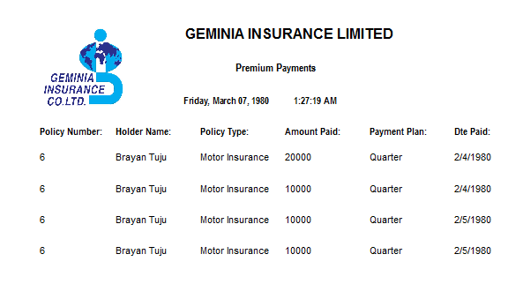

Figure 23:All Payments Report

## 3.6 Process Design

To achieve the aforementioned objectives, the following processes are done by the system.

The first operation is the reception registers the new agents recruited to work for the company. The agent’s details would then be saved which will help in printing of reports and agent’s payment. Agent’s details can be searched and retrieved whenever needed.

The agents are then required to bring in new customers to buy insurance. The registration of new customers is done and details of the new customers are saved in the database. The system automatically assigns a policy number which will help in identifying a specific policy holder. The policy agreement then sent to the underwriting manager who has admin rights to verify the contract and thereafter can accept or reject the policy. Details of the policy agreement can be fetched from the database whenever needed.

Policy Holder’s whose policies have been accepted are thereafter required to pay policy premiums. Details of the payment are recorded using the policy payment form and afterwards the system generates a receipt. The payment records can later be to print the reports.

In case a policy holder incurs a loss he/she is required to file a claim through the policy claim form. The claim becomes available to the claim manager who has admin rights and is responsible for verifying the claim. The claim manager then files a report based on the findings and can accept or reject the claim. The whole process is captured in the system and saved in the database.

Below is the system flow chart that shows the processes;

## 

Verification

Verification

Print Receipt

Policy registration

New Agent Registration

Main System Components

Username, Password

Figure 24:System Flowchart

Agents, Policy Holders, Payments, Insurance, Claims, Withdrawals

Report Processing

Save, Exit

Save, Exit

save, Exit

save, Exit

Premium payment

Policy Claim

Yes

No

If Username and Password = tTrue

## 3.7 Control Design

To achieve integrity of the system there is need to implement security measures that restricts access to the system for unauthorized users.

The following are the provided controls

(a). Hardware Controls: This involve the precautions put in place to ensure that all the physical parts of the system are safe secure.

1. Ensuring that the machines are maintained regularly so as to have optimal performance.
2. Limiting Unauthorized persons from interacting with the system by putting locks in the computer room.
3. Training the users of the system very well on how to operate with the computer devices connected to the system so as to improve efficiency.

(b). Software Controls: Controls put in place to ensure that the system is accessed by only authorized personnel.

1. Use of password to deny unauthorized access of access of records in the system.
2. Ensuring only valid data is processed.

## 3.8 Test Design

To ensure that every aspect of the system was working as per user requirements, I conducted certain test such as feeding wrong data. The following were the results.

**Test for Correct Data**

After being fed with correct data and no empty fields the system successfully saves the data to the database. A pop up message occurs to confirm successful operation.

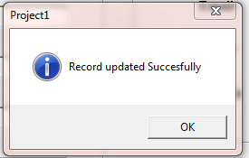

Figure 25:Correct Data

**Test for Incorrect Data**

The system rejects any invalid data and prompts the user to correct the inputs e.g. Empty field a user is prompted to fill in the field.

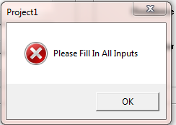

Figure 26:Incorrect Data

## 3.9 System Specification.

For the effective smooth running of the newly developed system certain hardware and software specification have to be considered, such specification includes;

**Hardware Specification.**

1. Branded computer of at least 2.5GHz processor speed, 2GB RAM with a hard disk capacity of at least 320GB ROM
2. Printer.

**Software Specification.**

1. Microsoft Windows 7 Ultimate Operating System.
2. Microsoft Access 2007.
3. Microsoft Visual Basic 6.0
4. Kaspersky antivirus.

# **CHAPTER FOUR**

## 4.0 System Implementation and Completion

## 4.1 Hardware and Software Specification

For the effective smooth running of the newly developed system certain hardware and software specification have to be considered such specifications include:

**Hardware Specification.**

1. Branded computer of at least 2.5GHz processor speed, 2GB RAM with a hard disk capacity of at least 320GB ROM
2. Printer.

**Software Specification.**

1. Microsoft Windows 7 Ultimate Operating System.
2. Microsoft Access 2007.
3. Microsoft Visual Basic 6.0

## 4.2 User Training

Training is a crucial phase into getting the users of the system to be able to use the system effectively, get the system to be acceptable to the users, improve quality operation and also reduce accidental error production when using the system due to unknowingly using the system without having any knowledge.

First training would be to all the users of the system that is the Branch Manager, underwriting manager, claim manager and receptionist. They would be trained on what the system does and what it’s all about in order to gain confidence and acceptance. A demonstration will be done to see how the system works. Users will be taught how to register new Agents, create new policy and record customer payments. More training would also be done on how to log in and out of the system.

## 4.3 Change Over

Due to many challenges encountered in the system in operation at Geminia, the urge to automatically curb this problem is to use the direct changeover technique whereby a complete adoption to use the newly developed system would have to be implemented and abandon all the processes that were conducted in the current system.

The advantage of using direct changeover is that all the processes are computerized, this in turn will reduce the labor force and paperwork used in the current system. Generally, the new system would reduce cost operation, increase productivity and increase performance.

## 4.4 System Security

In order to foresee security, the new system would enforce different security methods such as on the start running of the system, there will be a login pop up window whereby only authorized users would be able to login into the system therefore protecting unauthorized user access. The system will be installed with an antivirus that will always be up to date to protect the system from malware.

## 4.5 User Guide

A manual description on the use of the system would be provided in order to increase performance and productivity at Geminia. The manual document would showcase the different operations to be undertaken when using the system that is from setting the system up and running into bypassing the login and fully get access to the main system and carrying out different operations such as registering new policies, billing made and generating reports.

**User Guide Steps**

1. The system loads and the splash screen window appears.

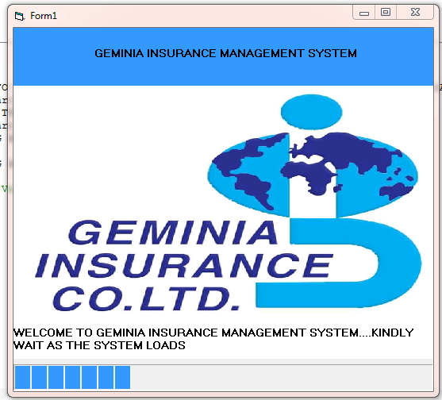

Figure 27:Splash Screen

1. After the splash screen finishes loading, the login window would be displayed whereby one will need to login.

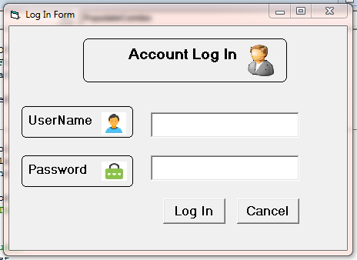

Figure :Login Form

1. After a successful login, the main system form would appear in which it will contain all the buttons and menu controls to carry out different operations in the system.

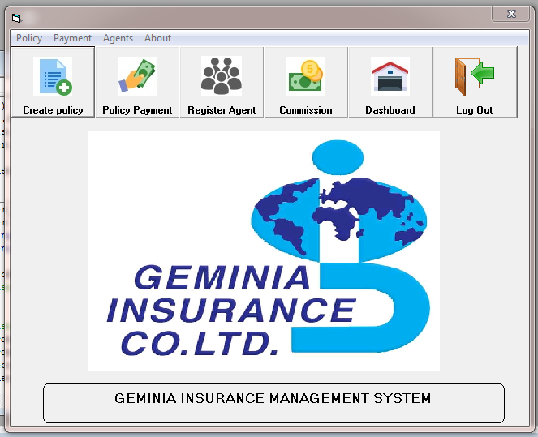

Figure 29:Main Page

## 4.6 Overall Conclusions

Despite many challenges experienced when designing and implementing the new system, I managed to achieve the stated objectives.

I did achieve my first objective of designing and implementing Geminia Management system through the use of hardware and software resources such as Microsoft Visual Basic 6.0 which provided so much capabilities of using different form tools such as textboxes, combo boxes and buttons to build a graphical user interface of capturing data, saving data and retrieving data from Microsoft Access 2007 Database. With the aid of hardware resources such as keyboard, mouse, printer and monitor it made easier for inputting data, outputting data and being able to visually manage data in the system.

On the second objective of computerizing the registration of new agents, I managed to achieve this objective by designing a user interface form that helped in capturing agent’s details. The employee details are saved in the database and database and updates every time a new agent is registered. The records are managed through different operations such as deleting records, generating reports and searching.

The third objective, computerizing registration of policy holders and claims. I managed to achieve this objective by designing a user interface form that helped in capturing new customer’s details. The details of the policy are then accessible to the underwriting manager who studies the details of the policy and accepts or rejects the policy agreement.

I also created a claim form where claimants’ details are captured and are accessible to the claim managers who verifies the claim and accepts or rejects according to the report obtained.

On the last objective of tracking the policy premium payment. I managed to achieve this objective through designing an interface form that helped in capturing insurance payment details into the system. The details are then saved to the database and automatically generate receipts to the transactions made.

Overall the entire operations at Geminia Insurance got to be improved by the new system in that a lot of work got to be computerized.

## 4.7 Achievements

Apart from the new system fulfilling the earlier stated objectives. The new system has greatly helped in various ways:

1. The new system has tremendously improved the processing speed of all operation in Geminia Insurance Limited by computerizing all the manual activities that was earlier involved in the current system, therefore maximizing productivity.
2. The new system has also greatly helped in positively reduce cost for both processing and maintenance thus is boosting the overall throughput of Geminia Insurance.

## 4.8 Limitations Constraints

During system design, I encountered a series of challenges. First, I had insufficient time carrying out the fact finding methods since not all personnel are friendly. Another challenge was working with VB6.0 proved challenging as code would behave differently at certain times. This led to over testing of the system. VB6.0 does not also have a wide community of developers hence it’s hard to seek help when you encounter a bug in your code.

## 4.9 Future Improvement

Due to the rise of new programming languages which all better than Visual Basic 6.0, I do tend to make the system be a web based system. Through the use of languages like HTML, CSS, JavaScript and PHP the system would have a more user friendly Graphical User Interface and be more efficient. This would enable users of Geminia Insurance system to carry out operations like creating policy on the tip of their phones website.

**References**

Website: ***projectsgeek.com/visual-basic-projects-with-source-code***

Books

*Title: Visual Basic PROGRAMMER’S GUIDE TO THE WINDOWS API*

*Author: Daniel Apple man*

*Title: Introduction Visual Basic 6.0*

*Author: Gary Haggard; wade Hutchison; Christy Shibata*.

**Appendix**

The following is the important code listing that was used to implement the system

**New Agent Registration Form**

Private Sub Check_Email(inp As Control)

Dim email As String

email = inp.Text

If InStr(1, email, "@") = 0 Then

MsgBox "Key In Valid Email"

inp.Text = ""

inp.SetFocus

End If

End Sub

Private Sub Check_input(inp As Control)

Dim strlen As Integer

strlen = Len(inp.Text)

If strlen > 10 Then

MsgBox "Number Should Not Exceed 10", vbCritical

inp.Text = ""

inp.SetFocus

ElseIf strlen <= 6 Then

MsgBox "Number Should not be Below Six Characters", vbCritical

inp.Text = ""

inp.SetFocus

End If

If Not IsNumeric(inp.Text) Then

MsgBox "Please input Numbers", vbCritical

inp.Text = ""

inp.SetFocus

End If

End Sub

Private Sub cmdDelete_Click()

If txtEmail.Text = "" And txtFullName.Text = "" And txtIdNumber.Text = "" And txtPhoneNumber.Text = "" And txtResidence.Text = "" And cboCounty.Text = "" And cboGender.Text = "" Then

Unload Me

frmMain.Show

Else

txtEmail.Text = ""

txtFullName.Text = ""

txtIdNumber.Text = ""

txtPhoneNumber.Text = ""

txtResidence.Text = ""

cboCounty.Text = ""

cboGender.Text = ""

End If

End Sub

Private Sub cmdSave_Click()

If txtEmail.Text = "" Or txtFullName.Text = "" Or txtIdNumber.Text = "" Or txtPhoneNumber.Text = "" Or txtResidence.Text = "" Or cboCounty.Text = "" Or cboGender.Text = "" Then

MsgBox "Please Fill In all Inputs"

Else

'save to database

dtaAgentRegistration.Recordset.AddNew

dtaAgentRegistration.Recordset.Fields(0).Value = txtIdNumber.Text

dtaAgentRegistration.Recordset.Fields(1).Value = txtPhoneNumber.Text

dtaAgentRegistration.Recordset.Fields(2).Value = cboGender.Text

dtaAgentRegistration.Recordset.Fields(3).Value = txtEmail.Text

dtaAgentRegistration.Recordset.Fields(4).Value = txtResidence.Text

dtaAgentRegistration.Recordset.Fields(5).Value = cboCounty.Text

dtaAgentRegistration.Recordset.Fields(7).Value = txtFullName.Text

dtaAgentRegistration.Recordset.Update

'Update User

MsgBox "Record updated Succesfully"

'Clear the Inputs

txtEmail.Text = ""

txtFullName.Text = ""

txtIdNumber.Text = ""

txtPhoneNumber.Text = ""

txtResidence.Text = ""

txtFullName.SetFocus

End If

End Sub

Private Sub Form_Load()

'Positioning the form

Top = (Screen.Height - Height) / 2

Left = (Screen.Width - Width) / 2

'Ensuring Inputs Are Empty

txtEmail.Text = ""

txtFullName.Text = ""

txtIdNumber.Text = ""

txtPhoneNumber.Text = ""

txtResidence.Text = ""

cboCounty.Text = ""

cboGender.Text = ""

End Sub

Private Sub Form_QueryUnload(Cancel As Integer, UnloadMode As Integer)

Unload Me

frmMain.Show

End Sub

Private Sub txtEmail_LostFocus()

Call Check_Email(txtEmail)

End Sub

Private Sub txtIdNumber_LostFocus()

Call Check_input(txtIdNumber)

End Sub

Private Sub txtPhoneNumber_LostFocus()

Call Check_input(txtPhoneNumber)

End Sub

**New Policy Holder Registration Form**

Private Sub Check_Email(inp As Control)

Dim email As String

email = inp.Text

If InStr(1, email, "@") = 0 Then

MsgBox "Key In Valid Email"

inp.Text = ""

inp.SetFocus

End If

End Sub

Private Sub PopulateCombo()

While dtaTypeOfAccount.Recordset.EOF = False

cboPolicyType.AddItem dtaTypeOfAccount.Recordset.Fields(2).Value

dtaTypeOfAccount.Recordset.MoveNext

Wend

End Sub

Private Sub Check_input(inp As Control)

Dim strlen As Integer

strlen = Len(inp.Text)

If strlen > 10 Then

MsgBox "Number Should Not Exceed 10", vbCritical

inp.Text = ""

inp.SetFocus

ElseIf strlen <= 6 Then

MsgBox "Number Should not be Below Six Characters", vbCritical

inp.Text = ""

inp.SetFocus

End If

If Not IsNumeric(inp.Text) Then

MsgBox "Please input Numbers", vbCritical

inp.Text = ""

inp.SetFocus

End If

End Sub

Private Sub cmdCancel_Click()

If txtAgentNumber.Text = "" And txtDateOfBirth.Text = "" And txtIdNumber.Text = "" And txtMobileNumber.Text = "" And txtName.Text = "" And txtNextOfKinName.Text = "" And txtNextOfKinPhoneNo.Text = "" And txtNextOfKinResidence.Text = "" And txtNextOfKinResidence.Text = "" And txtResidence.Text = "" And cboNextOfKinRelation.Text = "" And cboPolicyType.Text = "" And cboGender.Text = "" Then

Unload Me

frmMain.Show

Else

txtAgentNumber.Text = ""

txtDateOfBirth.Text = ""

txtIdNumber.Text = ""

txtMobileNumber.Text = ""

txtName.Text = ""

txtNextOfKinName.Text = ""

txtMobileNumber.Text = ""

txtNextOfKinPhoneNo.Text = ""

txtNextOfKinResidence.Text = ""

txtResidence.Text = ""

cboGender.Text = ""

cboNextOfKinRelation.Text = ""

cboPolicyType.Text = ""

End If

End Sub

Private Sub cmdProceed_Click()

Dim lngPhoneNumber As Long

Dim lngIdNumber As Long

Dim lngAgentNumber As Long, DateOfBirth As String

Dim lngKinPolicyNumber As Long

Dim lngkinPhoneNumber As Long

Dim strTypeOfPolicy As String

'Checking if all Inputs are entered

If txtAgentNumber.Text = "" Or txtDateOfBirth.Text = "" Or txtIdNumber.Text = "" Or txtMobileNumber.Text = "" Or txtName.Text = "" Or txtNextOfKinName.Text = "" Or txtNextOfKinPhoneNo.Text = "" Or txtNextOfKinResidence.Text = "" Or txtNextOfKinResidence.Text = "" Or txtResidence.Text = "" Or cboNextOfKinRelation.Text = "" Or cboPolicyType.Text = "" Or cboGender.Text = "" Then

MsgBox "Please Fill In All Inputs"

Else

'Saving details of policy applicant

lngPhoneNumber = txtMobileNumber.Text

lngIdNumber = txtIdNumber.Text

lngAgentNumber = txtAgentNumber.Text

strTypeOfPolicy = cboPolicyType.Text

dtaPolicyDetails.Recordset.AddNew

dtaPolicyDetails.Recordset.Fields(1).Value = txtName.Text

dtaPolicyDetails.Recordset.Fields(2).Value = lngIdNumber

dtaPolicyDetails.Recordset.Fields(3).Value = lngPhoneNumber

dtaPolicyDetails.Recordset.Fields(4).Value = txtResidence.Text

dtaPolicyDetails.Recordset.Fields(5).Value = cboPolicyType.Text

dtaPolicyDetails.Recordset.Fields(6).Value = cboGender.Text

dtaPolicyDetails.Recordset.Fields(7).Value = lngAgentNumber

dtaPolicyDetails.Recordset.Fields(8).Value = Format(Now, "mm/dd/yy hh:mm:ss")

dtaPolicyDetails.Recordset.Fields(9).Value = txtDateOfBirth.Text

dtaPolicyDetails.Recordset.Fields(10).Value = txtEmail.Text

dtaPolicyDetails.Recordset.Update

'Automating Inputs on the next Forms

dtaPolicyDetails.Recordset.MoveLast

lngPolicyNumber = dtaPolicyDetails.Recordset.Fields(0).Value

DateOfBirth = dtaPolicyDetails.Recordset.Fields(9).Value

lngAge = 2021 - Val(DateOfBirth)

'saving details of next of kin

lngkinPhoneNumber = txtNextOfKinPhoneNo

dtaNextOfKin.Recordset.AddNew

dtaNextOfKin.Recordset.Fields(0).Value = lngPolicyNumber

dtaNextOfKin.Recordset.Fields(1).Value = txtNextOfKinName.Text

dtaNextOfKin.Recordset.Fields(2).Value = lngkinPhoneNumber

dtaNextOfKin.Recordset.Fields(3).Value = cboNextOfKinRelation.Text

dtaNextOfKin.Recordset.Fields(4).Value = txtNextOfKinResidence.Text

dtaNextOfKin.Recordset.Update

MsgBox "Record Updated Succesfully", vbInformation

'Clearing Inputs

txtAgentNumber.Text = ""

txtDateOfBirth.Text = ""

txtIdNumber.Text = ""

txtMobileNumber.Text = ""

txtName.Text = ""

txtNextOfKinName.Text = ""

txtNextOfKinPhoneNo.Text = ""

txtNextOfKinResidence.Text = ""

txtResidence.Text = ""

cboGender.Text = ""

cboNextOfKinRelation.Text = ""

cboPolicyType.Text = ""

'Choosing Page

If strTypeOfPolicy = "Fire and Perils Insurance" Then

Unload Me

Unload frmMain

frmFirePerils.Show

ElseIf strTypeOfPolicy = "Motor Insurance" Then

Unload Me

Unload frmMain

frmMotorInsurance.Show

ElseIf strTypeOfPolicy = "Accident Insurance" Then

Unload Me

Unload frmMain

frmAccidentInsurance.Show

Else

Unload Me

Unload frmMain

frmPolicyPayment.Show

End If

End If

End Sub

Private Sub Form_Load()

'Positioning the form

Top = (Screen.Height - Height) / 2

Left = (Screen.Width - Width) / 2

Call PopulateCombo

End Sub

Private Sub Form_QueryUnload(Cancel As Integer, UnloadMode As Integer)

Unload Me

frmMain.Show

End Sub

Private Sub txtEmail_LostFocus()

Call Check_Email(txtEmail)

End Sub

Private Sub txtIdNumber_LostFocus()

Call Check_input(txtIdNumber)

End Sub

Private Sub txtMobileNumber_LostFocus()

Call Check_input(txtMobileNumber)

End Sub

Private Sub txtNextOfKinPhoneNo_LostFocus()

Call Check_input(txtNextOfKinPhoneNo)

End Sub

**Policy Claim Form**

Private Sub PopulateCombo()

While dtaAcceptedPolicies.Recordset.EOF = False

If dtaAcceptedPolicies.Recordset.Fields(4).Value = "Accepted" Then

cboPolicyNumber.AddItem dtaAcceptedPolicies.Recordset.Fields(0).Value

End If

dtaAcceptedPolicies.Recordset.MoveNext

Wend

End Sub

Private Sub cboPolicyNumber_Click()

Dim lngTempPolicyNumber As Long

lngTempPolicyNumber = cboPolicyNumber.Text

'Filling in type of insurance and user

dtaAcceptedPolicies.Recordset.MoveFirst

dtaAcceptedPolicies.Recordset.Find "[Policy Number]= " & lngTempPolicyNumber, 0, adSearchForward

If dtaAcceptedPolicies.Recordset.EOF = True Then

dtaAcceptedPolicies.Recordset.MoveFirst

ElseIf dtaAcceptedPolicies.Recordset.Fields(0).Value = lngTempPolicyNumber Then

txtClaimantName.Text = dtaAcceptedPolicies.Recordset.Fields(1).Value

txtClaimType.Text = dtaAcceptedPolicies.Recordset.Fields(2).Value

End If

End Sub

Private Sub cmdCancel_Click()

If txtClaimantName.Text = "" And txtClaimType.Text = "" And cboPolicyNumber.Text Then

frmMain.Show

Else

txtClaimantName.Text = ""

txtClaimType.Text = ""

cboPolicyNumber.Text = ""

End If

End Sub

Private Sub cmdProceed_Click()

Dim ClaimType As String

Dim PolicyNumber As Long

ClaimType = txtClaimType.Text

If txtClaimantName.Text = "" Or txtClaimType.Text = "" Or cboPolicyNumber.Text = "" Then

MsgBox "Please Fill In All Inputs", vbCritical

Else

PolicyNumber = cboPolicyNumber.Text

'Saving to Database

dtaPolicyClaim.Recordset.AddNew

dtaPolicyClaim.Recordset.Fields(0).Value = PolicyNumber

dtaPolicyClaim.Recordset.Fields(1).Value = txtClaimantName.Text

dtaPolicyClaim.Recordset.Fields(2).Value = txtClaimType.Text

dtaPolicyClaim.Recordset.Update

ClaimantPolicyNumber = cboPolicyNumber.Text

ClaimantName = txtClaimantName.Text

txtClaimantName.Text = ""

txtClaimType.Text = ""

cboPolicyNumber.Text = ""

'Saving Claim Number

dtaPolicyClaim.Recordset.MoveLast

ClaimNumber = dtaPolicyClaim.Recordset.Fields(3).Value

If ClaimType = "Motor Insurance" Then

frmMotorClaim.Show

ElseIf ClaimType = "Fire and Perils Insurance" Then

frmFireAndPerilsClaim.Show

ElseIf ClaimType = "Accident Insurance" Then

frmAccidentClaim.Show

End If

End If

End Sub

Private Sub Form_Load()

'Positioning the form

Top = (Screen.Height - Height) / 2

Left = (Screen.Width - Width) / 2

Call PopulateCombo

End Sub

Private Sub Form_QueryUnload(Cancel As Integer, UnloadMode As Integer)

frmMain.Show

End Sub